Le Rocher Le Vieux
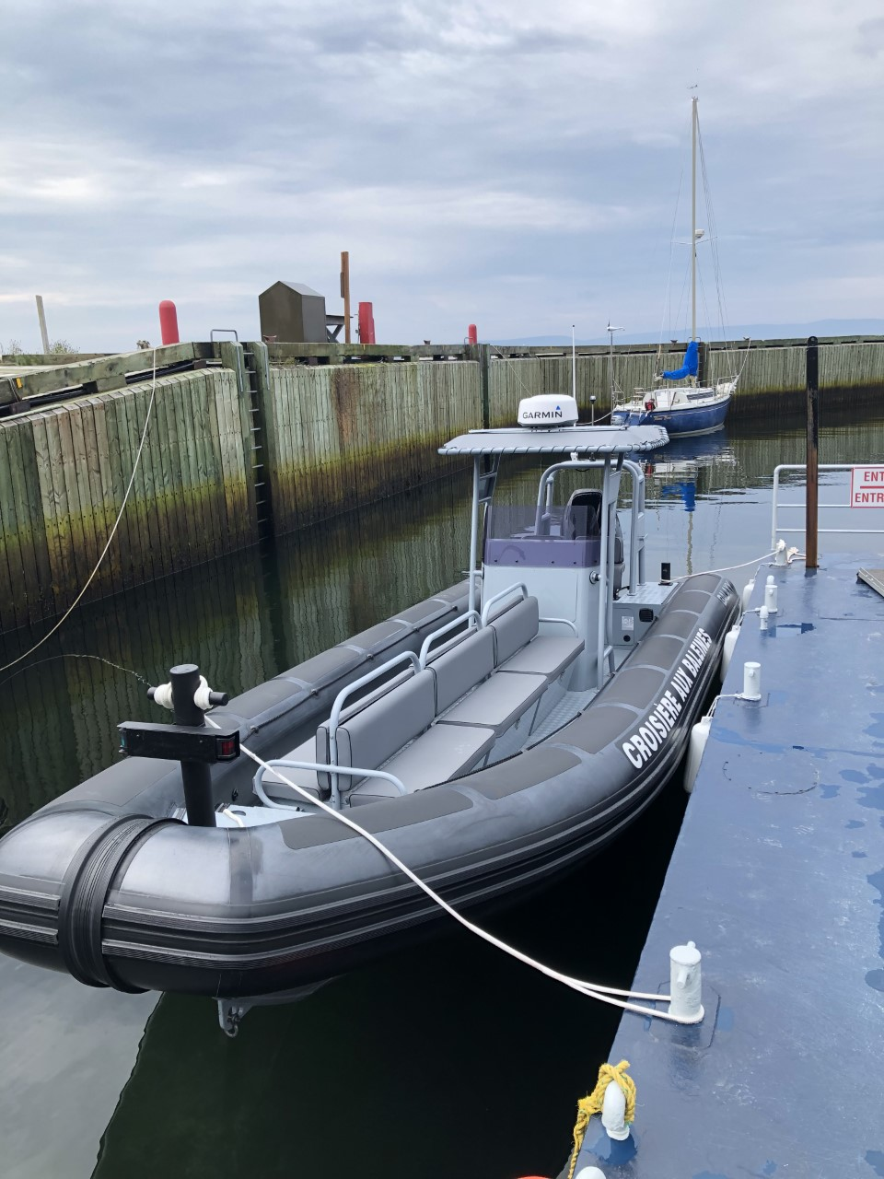 Le Rocher Le Vieux is the ideal type of boat for whale watching. It is a fast, safe and comfortable vessel. The speed of Rocher Le Vieux allows a better approach and a longer observation time of the whale before it dives into the sea.

Technical data sheet

Ship with a maximum capacity of 12 passengers
Aluminum shell and HYPALON tube
Propulsion: 1 Suzuki 300 HP engine
Certification by Transport Canada and the Commission des Transports du Québec
Complete electronic equipment: radar, sounder, G.P.S., radio V.H.F

